Advanced Driver Assistance System: Analytics for Road Safety

# Project Overview:

This project aims to develop an advanced driver assistance system (ADAS) by leveraging computer vision techniques. The system will primarily focus on two core functionalities—vehicle recognition and lane recognition—while integrating additional features such as distance estimation, object tracking, and lane departure analysis. By processing real-time video feeds from onboard cameras, the solution will detect vehicles, identify lane markers, and estimate the distance to surrounding objects. This comprehensive approach enhances situational awareness and provides actionable insights to support safe driving.

Rationale & Market Relevance:

Road safety remains a critical global challenge, with human error being a leading cause of accidents. Current ADAS technologies have demonstrated that timely detection of road elements can significantly reduce accident risks. This project addresses the following market needs:

* **Enhanced Safety:** By combining vehicle and lane recognition with distance estimation and object tracking, the system offers a robust safety net for drivers, potentially reducing collision risks.
* **Cost-Effective Solution:** Utilizing open-source computer vision libraries and readily available hardware makes the system an attractive proposition for automotive manufacturers and aftermarket solutions.
* **Scalability:** The modular design allows for integration of additional features (e.g., traffic sign recognition, pedestrian detection) to meet future market demands.
* **Research & Development:** This project contributes to academic and industrial research in computer vision, offering a testbed for experimenting with state-of-the-art algorithms in real-world scenarios.

# Workflow & Methodology

The project will be developed using Python and will integrate several libraries and frameworks, including OpenCV for image processing and TensorFlow/PyTorch for deep learning models. The methodology is divided into the following key steps:

## Data Collection & Preprocessing:

Capture video data from multiple sources (simulated or real-world driving scenarios).

Preprocess images (resizing, normalization, noise reduction) to prepare for model training and inference.

## Model Development:

1. **Vehicle Recognition:** Train and implement convolutional neural networks (CNNs) to detect and classify vehicles.
2. **Lane Recognition:** Utilize edge detection and Hough Transform techniques combined with deep learning for robust lane detection.
3. **Distance Estimation:** Employ monocular depth estimation or stereo vision techniques to calculate the distance between the vehicle and surrounding objects.
4. **Object Tracking & Additional Analysis:** Implement tracking algorithms (e.g., SORT, DeepSORT) to monitor vehicle trajectories and analyze lane departure or curvature for further safety warnings.
5. **System Integration:**

* Develop a pipeline that integrates all functionalities into a cohesive system.
* Ensure real-time performance by optimizing the processing pipeline and leveraging hardware acceleration where possible.

1. **Testing & Validation:**

* Evaluate system performance using benchmark datasets and real-time testing.
* Fine-tune models based on accuracy, speed, and robustness under various driving conditions.

**ERD & Workflow Diagram:**

An Entity Relationship Diagram (ERD) will illustrate the interaction among system components, including input (camera module), processing units (image preprocessor, detection and estimation modules), and output (driver alert system).

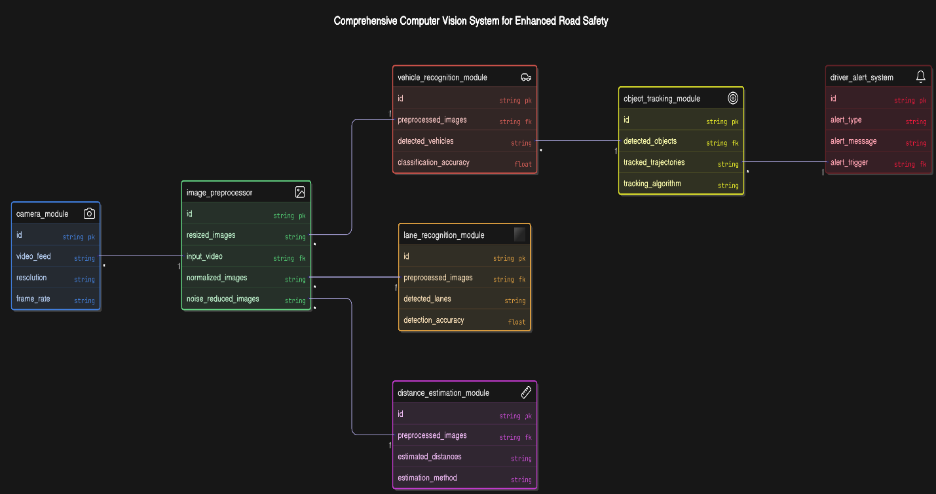

A workflow diagram will depict the sequential process: from data capture and preprocessing to detection, distance calculation, tracking, and driver notification.

